
North South University
Department of Electrical and Computer Engineering
FINAL PROJECT REPORT BY GROUP-5
“Fotoboo”
CSE299 SECTION 10 SPRING 2022
Course Faculty: Syeda Sarita Hassan (Lecturer)
Mohammed Ahnaf Abid 1931897642 Project name: “Fotoboo”
Saida Iman 1931165642 Group name: “Fotoboo”
Eatrat Zerin 1831242642 Group number: 5
Amatullah Tyba 1911345642
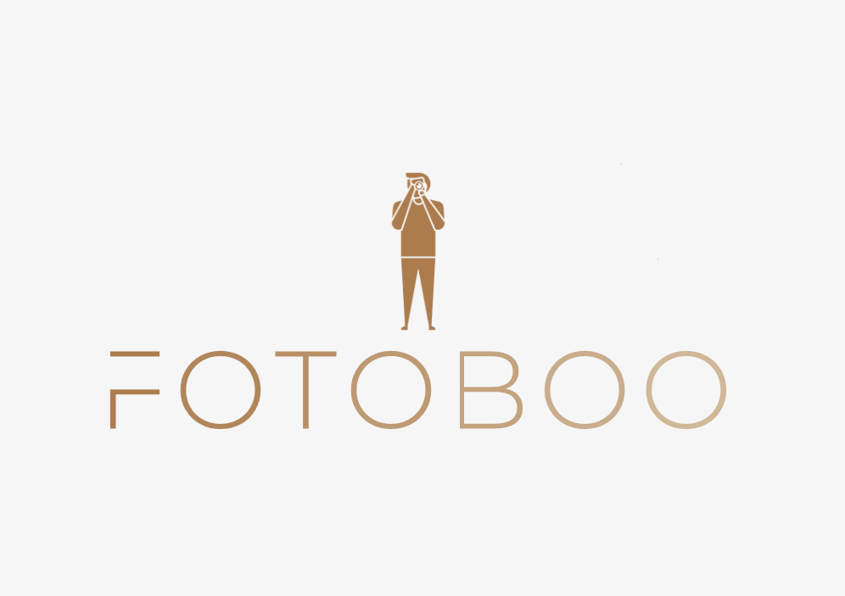

TABLE OF CONTENTS

Subheadings: | Page no:
Abstract | 4
Literature Review | 5
Aim | 7
Application of Project | 8
Tools | 9
Schematic Diagram | 10
Use-Case Diagram | 11
Process of Work | 12
Timeline of Work | 13
Design & Implementation | 14
Results & Evaluation | 26
Future Improvements | 38
Conclusion | 39
References | 40

Abstract
Fotoboo, is the first professional online match-making platform for clients and photographers in Bangladesh. It is a unique platform where professional photographers are hired by Fotoboo after a series of strenuous tests and extensive background-research in order to provide the most qualified photographers for a myriad of different events whether it be public or private. Each and every photographer are professionals who put their curated portfolios on our website. Our customers can search the photographer of their choice by searching by categories such as weddings, birthdays, fashion, corporate events etc. There is also an online rating system distinguishing the individual photographer’s performance so that customers have a freedom of choice, based on the real reviews left on the website by past clients.

Literature Review
Who is the target audience for Fotoboo?
Target audience refers to the specific group of consumers who are the most likely candidates to use our service and they may be differentiated from others by the properties of age, gender, income, location, interests etc. In the case of Fotoboo, our target audience is the demographic who usually fall under teenagers to adults who are either hosting an event or are a part of an event management team. Numerous birthdays, weddings, fashion shows, corporate events and travelling vlogs are held every year, there is a massive market for the hire of professional photographers which Fotoboo is going to cater to.

What is the current situation of the photography market in Bangladesh?
The photography market of Bangladesh is disorganized and there is no proper and trustworthy website to look for well-trained photographers. There is also a problem of growing unemployment in the professional market space for photographers. Fotoboo is on a mission to cater to the neglected photography market by providing an organized, professional website where our clients can look for professional photographers and go through their portfolios which also contain their ratings. Fotoboo is also providing jobs for these unemployed photographers provided that they meet Fotoboo’s strict standards.

What are the notable features of Fotoboo?
Fotoboo has a photographer rating system which cannot be found elsewhere in Bangladesh. It is guaranteed to display honest reviews from actual customers, written based on their past experience along with the ability to attach the pictures that were taken by their hired photographer. This builds the trust of our future clients and strengthens the bond between Fotoboo and its existing customer-base because we strive to provide the best services possible.

Fotoboo also has an innovative dark-mode setting which is easier on the eyes of the viewer. Furthermore, they can easily switch back to light-mode if they desire.

Aims
- Matchmaking between prospective clients and professional photographers
- Easy-to-use website with clear instructions
- Free user account registration and login along with account verification
- Family-friendly website – can be used by both teenagers and adults
- Sleek and minimalistic user-interface
- Ad-free user-interface (No intrusive pop-up ads or ad banners)
- Eye-friendly dark-mode setting; which can be switched based on user preference
- Review/Rating System of photographers for easier choice-making
- All photographers are going to be trained to maintain COVID-prevention protocols set by World Health Organization (ex: wearing masks)

Application of Project
Fotoboo is a website which can be accessed by laptop or desktop computers as well as on mobile phone browsers. Users can create their accounts and browse through our wide-range of categories based on the event type that they are involved in. They can hire their photographer of choice based on individual portfolios and honest client reviews.

Tools
IDLE (Integrated Development Environment):
- Visual Studio Code
Localhost Webserver:
- Xampp
- phpMyAdmin
FRONTEND:
- HTML
- CSS
- BOOTSTRAP
- JAVASCRIPT
BACKEND & DATABASE:
- PHP
- SQL
Schematic Diagram

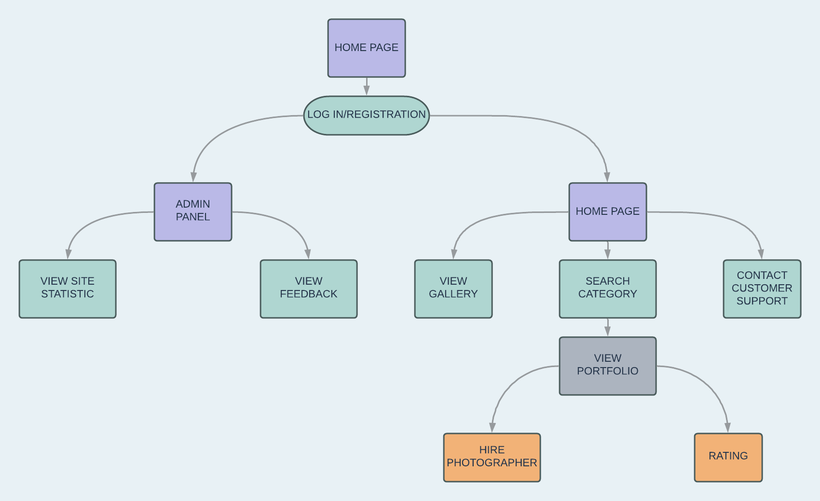
Use-Case Diagram
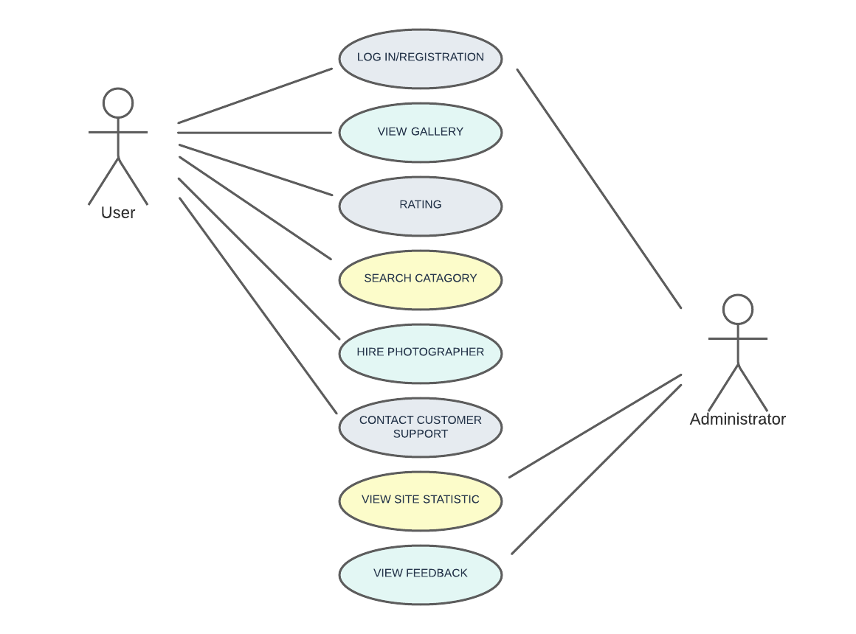

Process of work
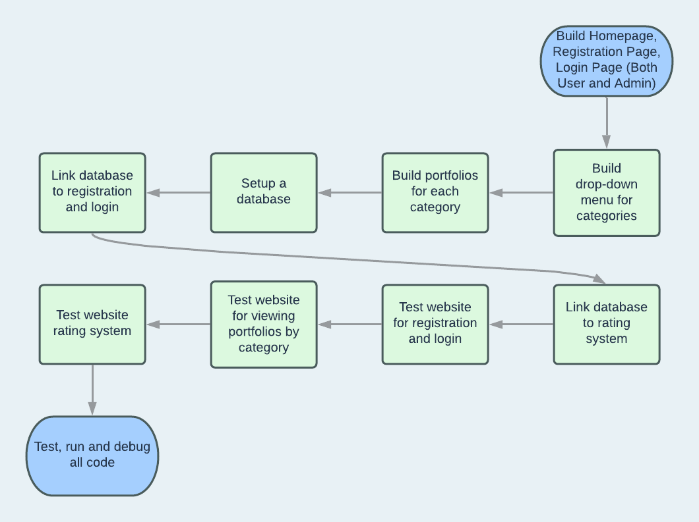

Timeline of work

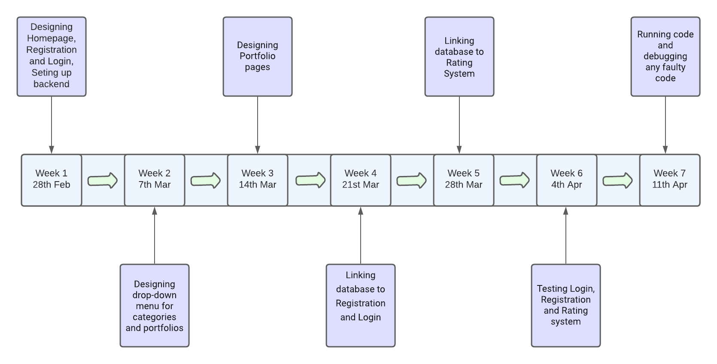

Design & Implementation
- All pages were designed using HTML, CSS and JavaScript.

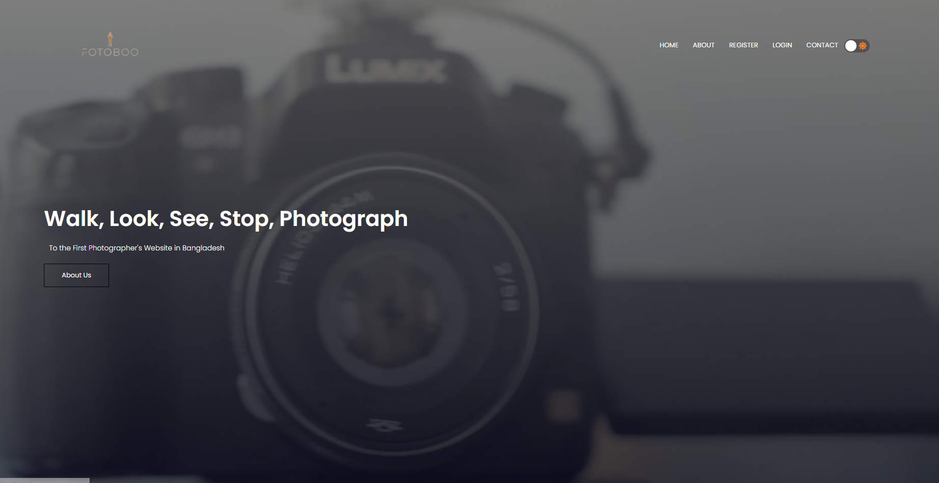
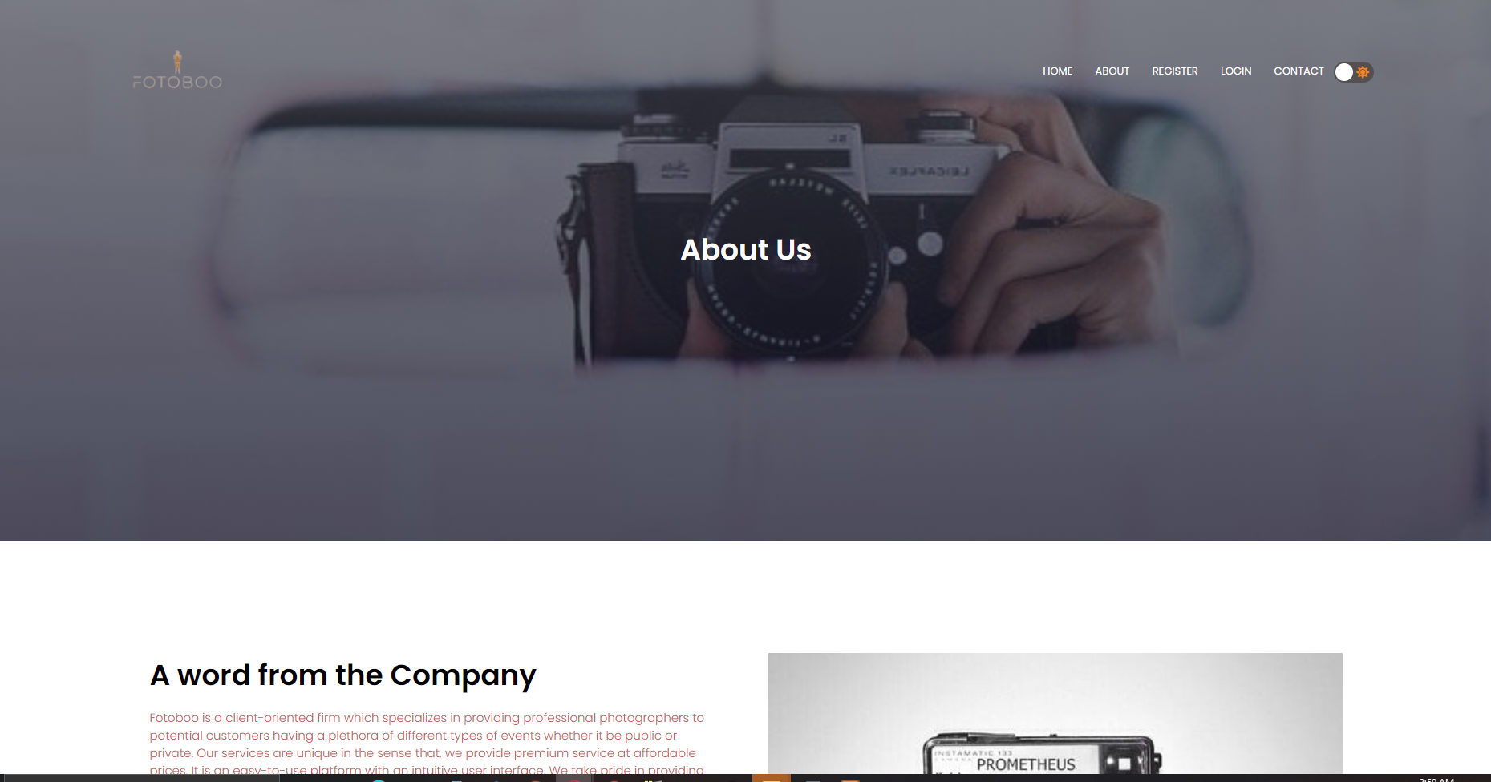

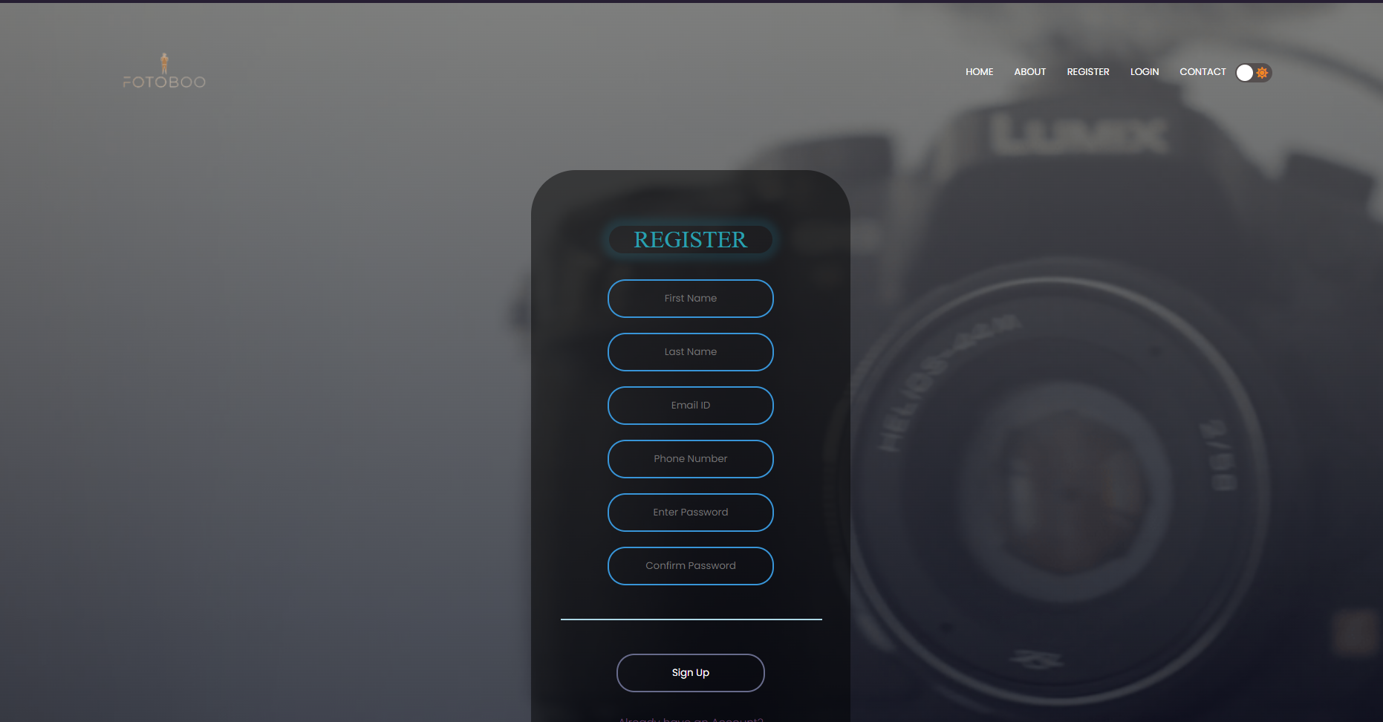

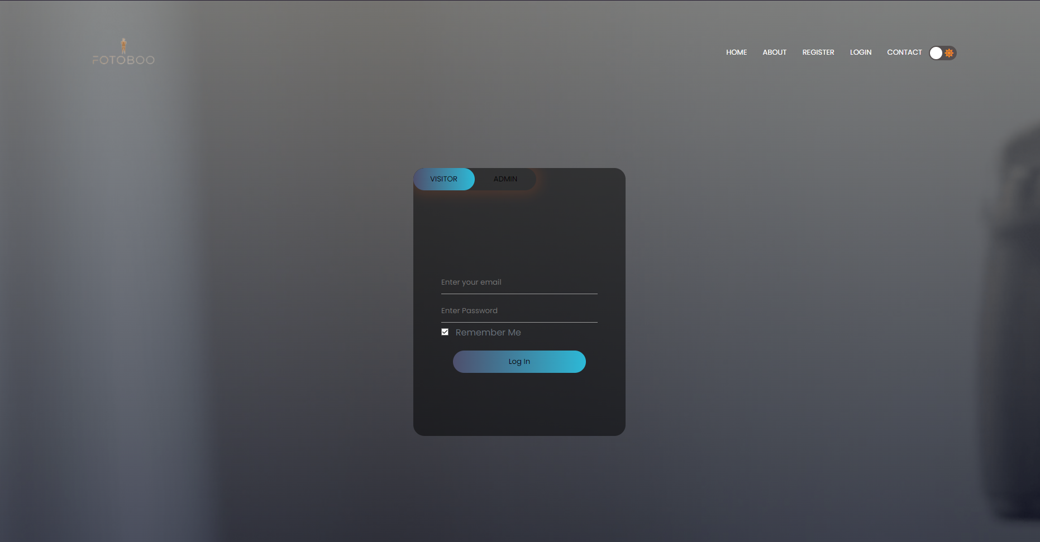

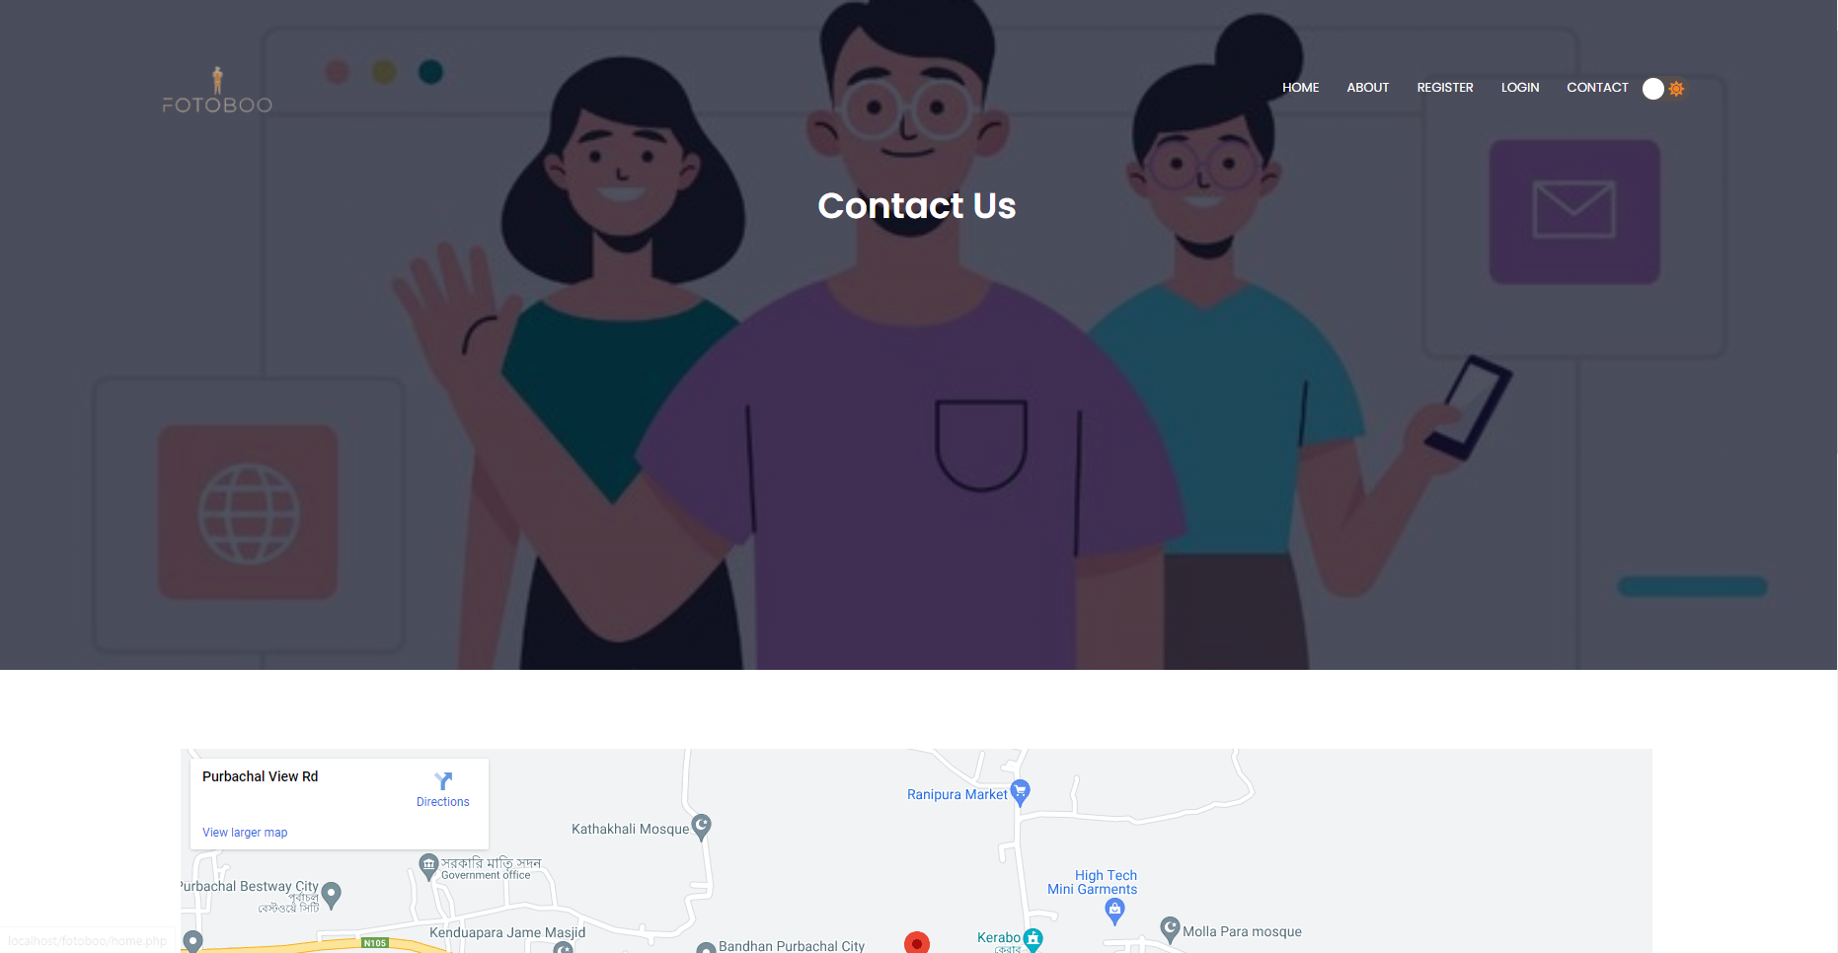

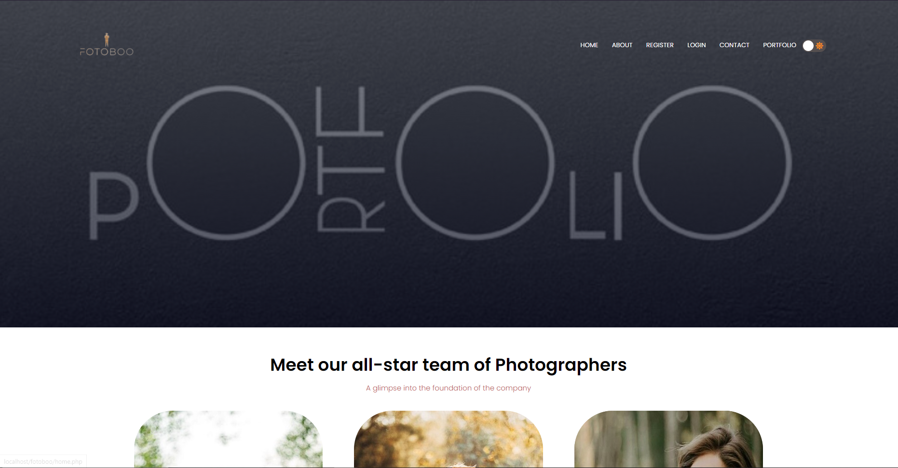
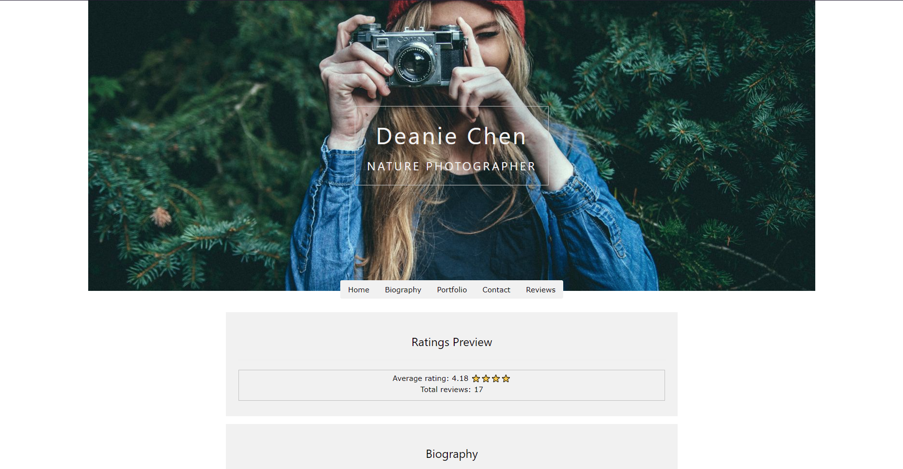
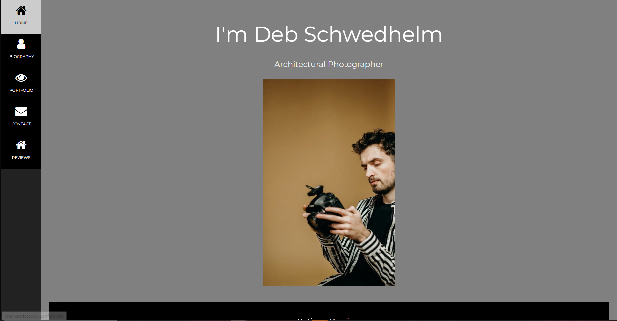

- All the pages were connected to database using PHP.
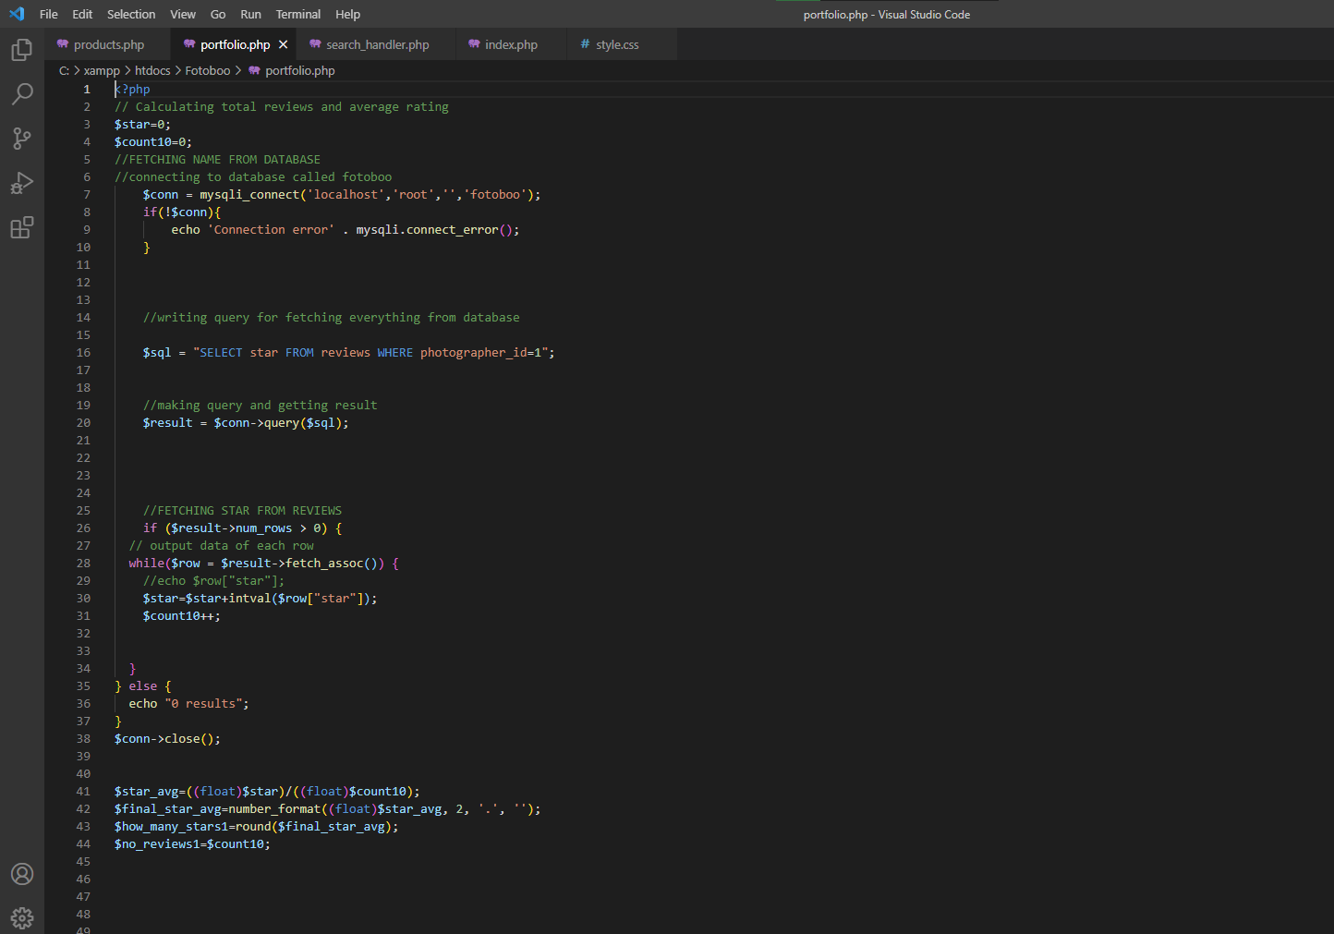
- Database was setup with the appropriate tables for data entry.
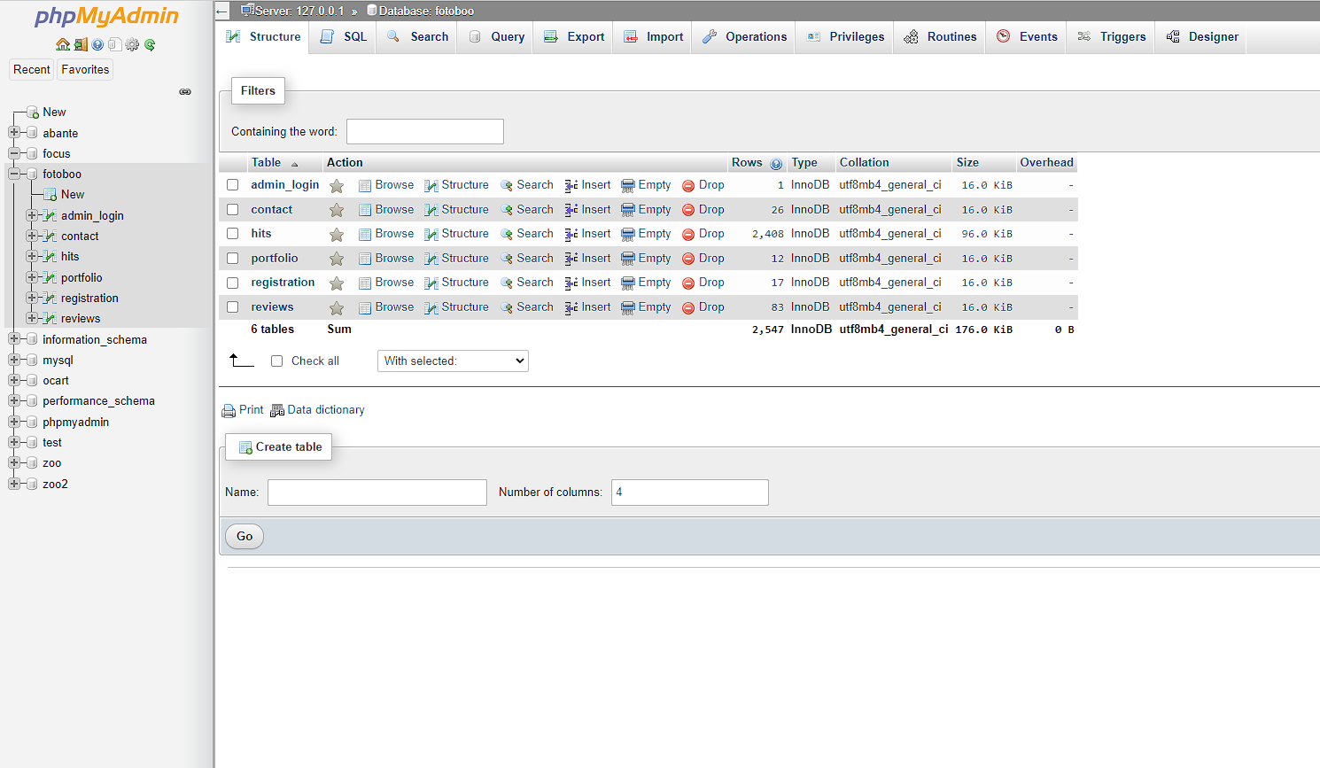
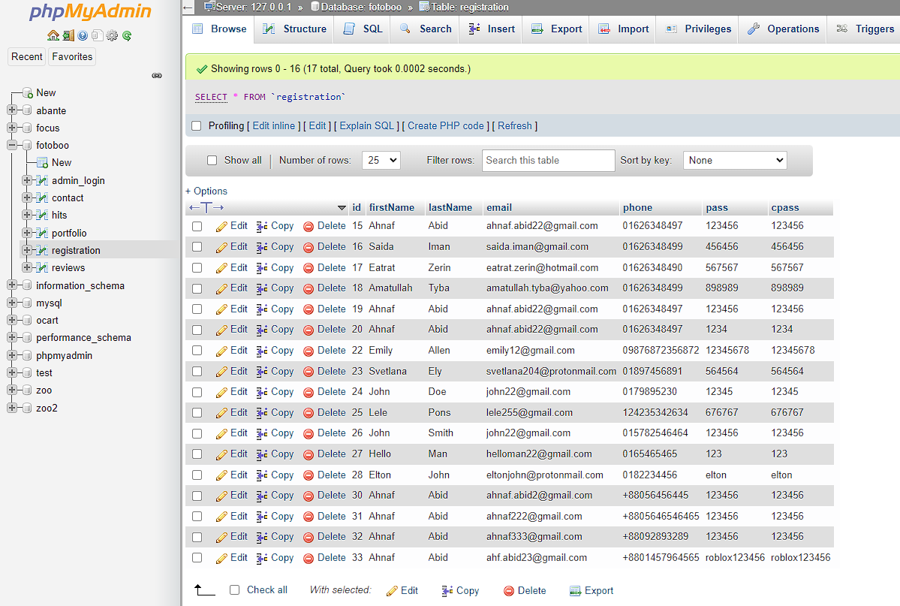
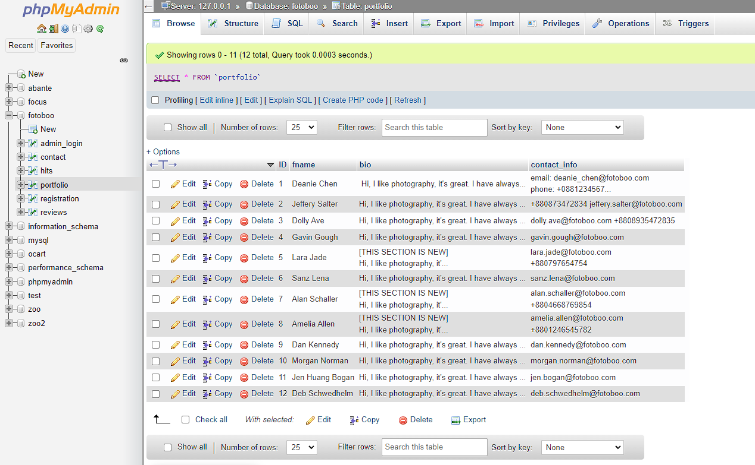

Results & Evaluation
- The user can use the top nav bar for easy navigation which turns into hamburger menu on mobile devices.


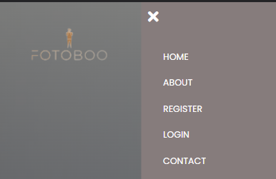
- The user can register on the registration form.
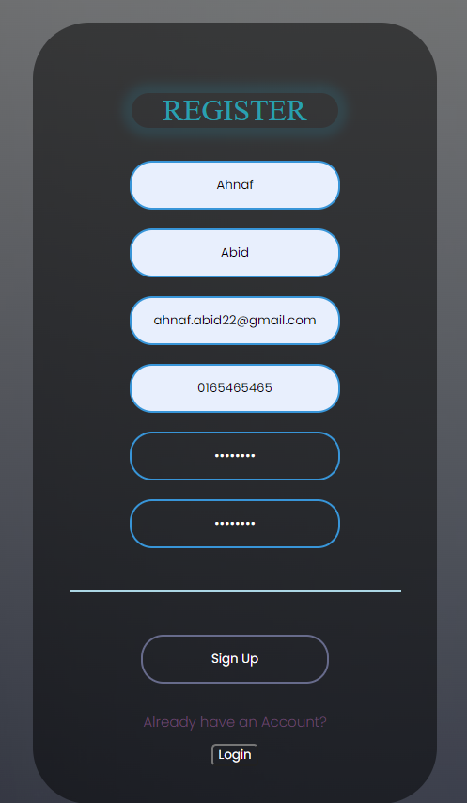

- The user can login using login form.
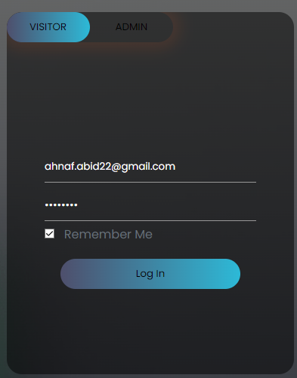

- The user can leave feedback on contact page.
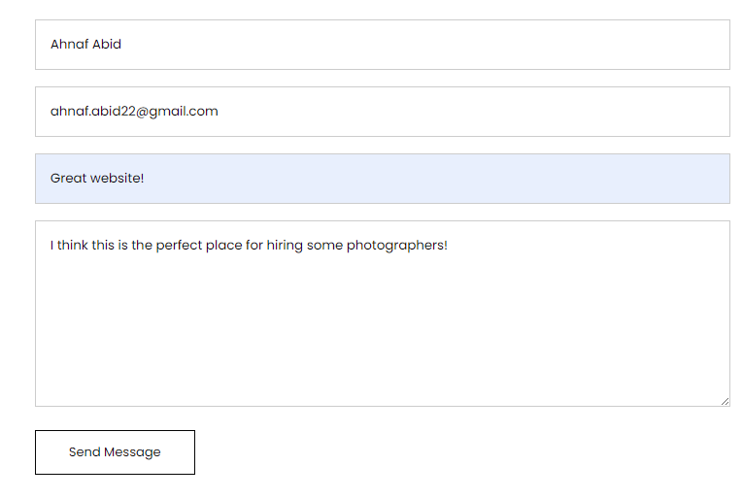

- The user can access the portfolio page.
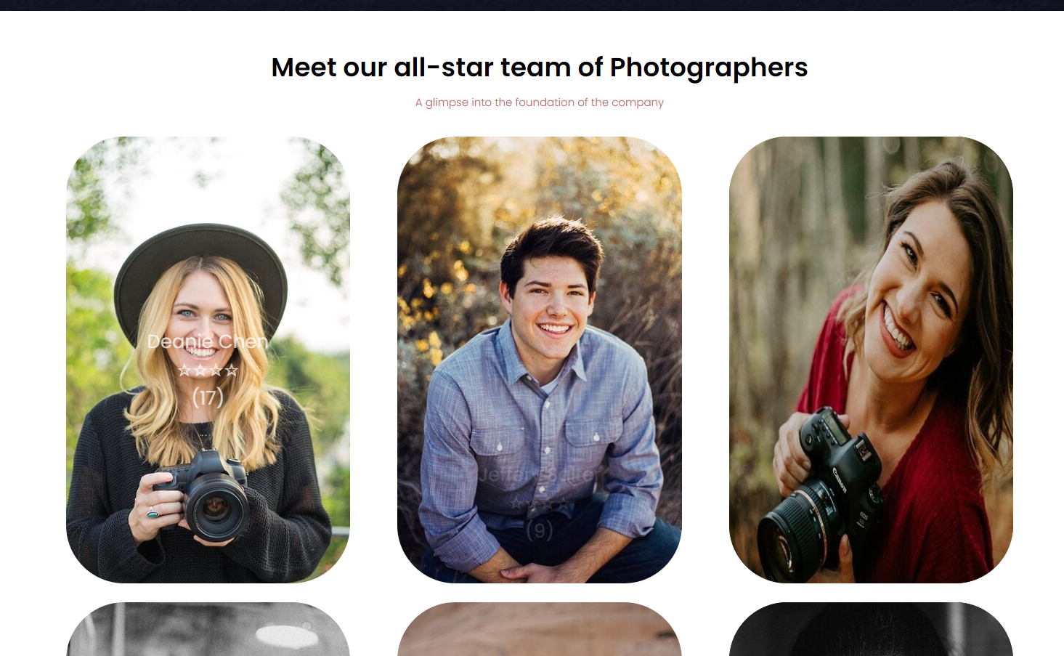

- The user can access the individual portfolios.
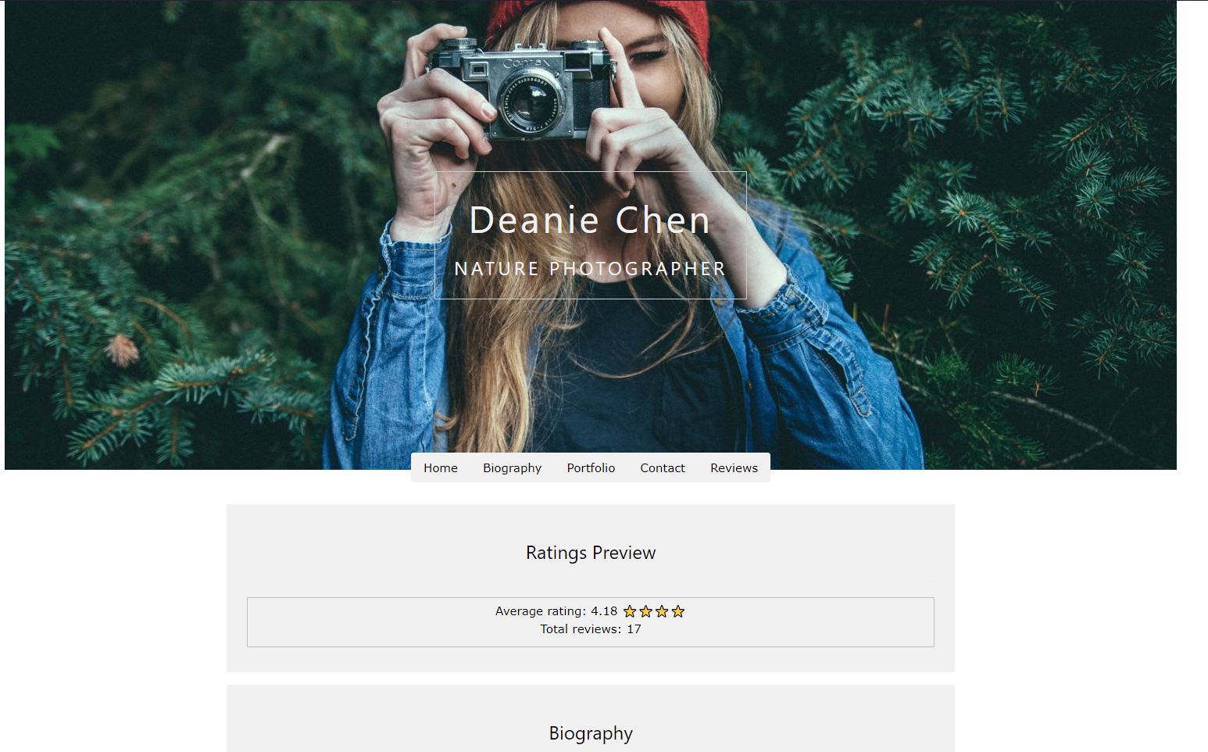
- The user can leave a star-based rating along with a review.
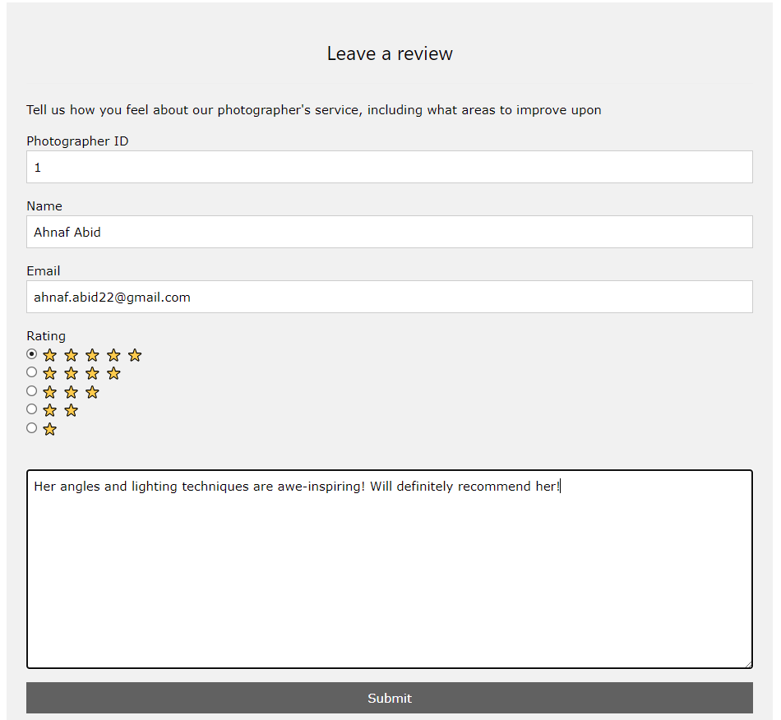
- The admin can login using admin login form.
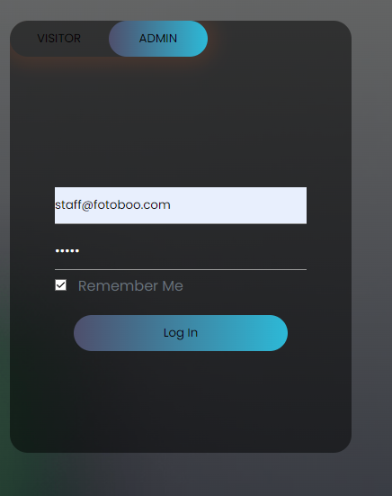
- Admin can view site stats.
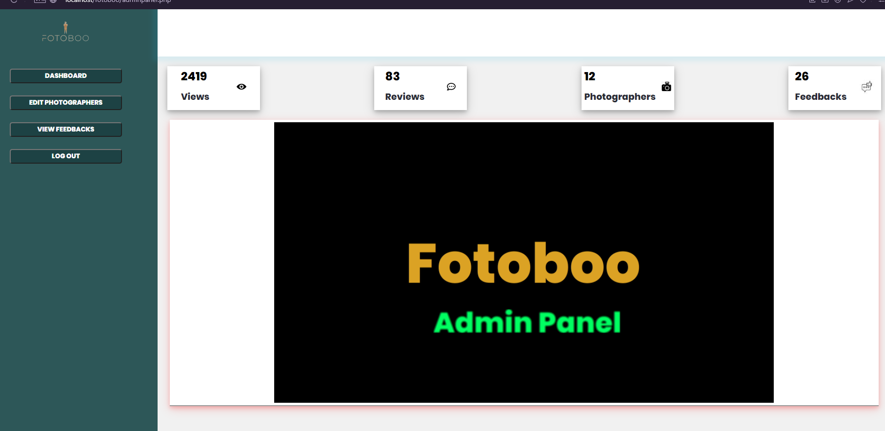
- Admin can view feedbacks.
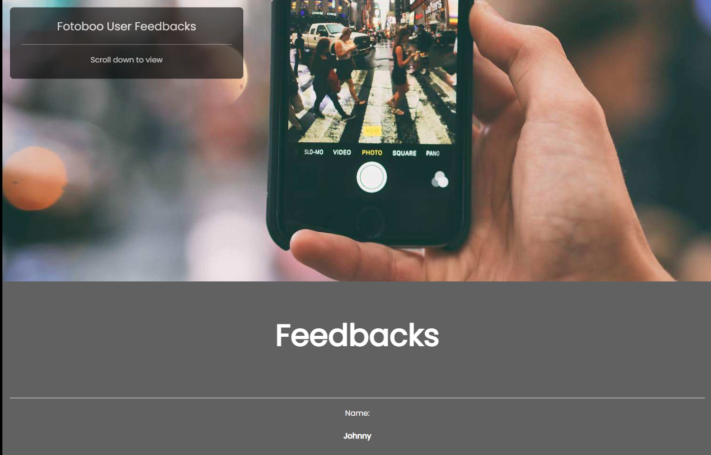

- Admin can Edit Photographer info on a per-name basis.

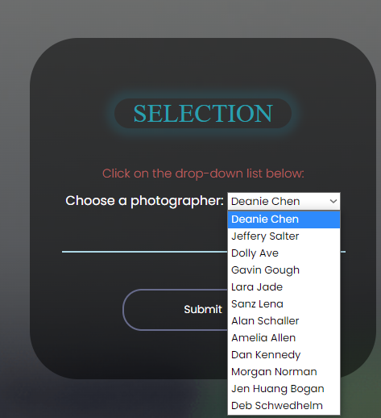
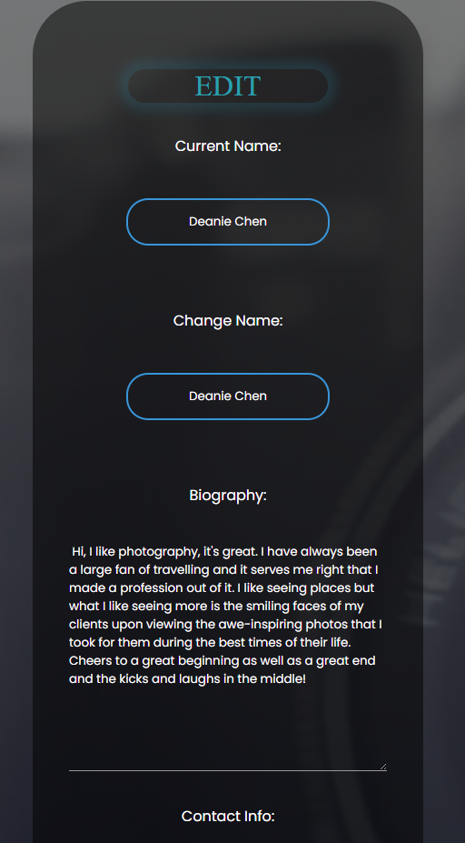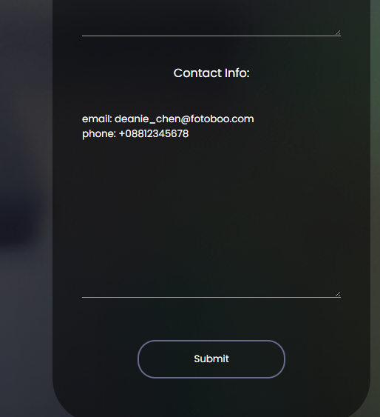
Future Improvements
- The website can be adapted to include both bank transactions and online payment systems such as bKash, Nagad and Rocket.
- The website can be made to actively track user account location and provide location-based services.
- The website can be turned into a mobile app that can be downloaded off of Google Playstore or Apple App Store.
- The website can provide a send CV feature for future, aspiring photographers to send in their resumes.
- The website can include a videos section for videographers as well.
- The website can add a donation feature to ask for funds for helping the underprivileged demographic of our country with every transaction.

Conclusion
The purpose of this project, which is mentioned in this paper, is to create an easily accessible website where clients can choose the category of particular events and based on that category, the client is going to be shown meticulously crafted portfolios. This website is a well-organized platform maintaining industry standards.

References
[1] https://www.marketingevolution.com/marketing-essentials/target-audience
[2] https://en.wikipedia.org/wiki/Photography_in_Bangladesh
[3] https://en.wikipedia.org/wiki/Visual_Studio_Code
[4] https://en.wikipedia.org/wiki/Bootstrap_(front-end_framework)
[5] https://en.wikipedia.org/wiki/HTML
[6] https://en.wikipedia.org/wiki/JavaScript
[7] https://en.wikipedia.org/wiki/PHP
[8] https://en.wikipedia.org/wiki/SQL
[9] https://en.wikipedia.org/wiki/XAMPP

